**INTRODUCTION TO PROJECT**

**Research Problem:**

* The research problem could be framed as the inefficiencies and complexities faced by hotels in managing room bookings manually or with outdated systems. These inefficiencies might include overbooking, double bookings, difficulty in managing room availability, and inadequate customer data management.

**Proposed Solutions:**

* The proposed solution could involve the development of a comprehensive hotel booking room management system that automates the booking process, manages room availability in real-time, integrates with other hotel systems (such as billing and customer management), and provides a user-friendly interface for both hotel staff and customers.

**Objectives:**

1. To automate the room booking process to reduce errors and improve efficiency.
2. To provide real-time availability updates for customers and staff.
3. To integrate with other hotel systems for seamless operations.
4. To improve customer experience through easy booking and personalized services.
5. To enhance data management for better decision-making.

**Project Activities, Outcome, Output, Goals, and Impact:**

**Activities**:

Research existing systems, design system architecture, develop software, test for functionality and reliability, deploy system, provide training and support.

**Outcome**:

A fully functional hotel booking room management system.

**Output**:

User manuals, training materials, software documentation.

**Goals**:

Improve efficiency, reduce errors, enhance customer satisfaction, increase revenue.

**Impact**:

Streamlined operations, better customer service, increased profitability.

**Develop Proof of Concept:**

* This involves creating a small-scale version of the system to demonstrate its feasibility and effectiveness. It may include developing a prototype with basic functionality to showcase key features and validate the concept before investing in full-scale development.

**LOGICAL FRAMEWORK**

|  |  |  |  |  |
| --- | --- | --- | --- | --- |
|  | **PROJECT SUMMARY** | **INDICATORS** | **MEANS OF VERIFICATION** | **RISKS/ ASSUMPTION** |
| **GOAL** | Develop and implement a comprehensive hotel booking room management system to revolutionize the hospitality industry by streamlining hotel operations, enhancing customer experience, and increasing revenue for hotels. | Indicators relate to measurable elements that show progress towards your goals:  **Increased Hotel Profitability:** Quantitative Indicator: **Average increase in hotel revenue and booking conversion rates (e.g., 10%)** Means of Verification: **Hotel financial reports demonstrating revenue growth.**  **Enhanced Customer Experience:** Qualitative Indicator: **Positive feedback from customers regarding ease of booking and improved service.**  Means of Verification: **Customer satisfaction surveys conducted after using the system and online review analysis of hotels using the system.** | This section details methods for confirming achievement of indicators:  System usage reports generated by the system itself (e.g., logins, bookings made).  Hotel financial reports demonstrating revenue growth.  Customer satisfaction surveys conducted after using the system.  Online review analysis of hotels using the system. | **Risk:** Difficulty gaining initial market traction and convincing hotels to switch from existing systems.  Mitigation Strategy: Develop a strong marketing and sales strategy highlighting the system's benefits and competitive advantages.  **Assumption:** Openness from hotels to explore and adopt new technologies for streamlining operations.  Validation Strategy: Conduct market research to gauge hotel receptiveness to new technologies and tailor the system's features to address their needs. |
| **OUTCOMES** | Develop and implement a comprehensive hotel booking room management system to revolutionize the hospitality industry by streamlining hotel operations, enhancing customer experience, and increasing revenue for hotels. | Develop and implement a comprehensive hotel booking room management system to revolutionize the hospitality industry by streamlining hotel operations, enhancing customer experience, and increasing revenue for hotels. Example **Increase Hotel Profitability:** This indicator reflects the project's overall goal of improving hotel revenue. Quantitative Indicator: **Average increase in hotel revenue and booking conversion rates (example., 10%)**  **Enhanced Customer Experience:** This indicator aligns with the goal of improving customer satisfaction. Qualitative Indicator: **Positive feedback from customers regarding ease of booking and improved service.** | This section defines how you'll confirm whether the indicators are being met, essentially verifying if you're achieving the desired outcome. It specifies the methods and tools used to gather data and evidence:  **Hotel financial reports demonstrating revenue growth** would verify the "Increased Hotel Profitability" indicator.  **Customer satisfaction surveys conducted after using the system and online review analysis of hotels using the system** would verify the "Enhanced Customer Experience" indicator. | **Risk:** Difficulty gaining initial market traction and convincing hotels to switch from existing systems. This could prevent widespread adoption and hinder the project's goal of revolutionizing the industry. **Assumption:** Openness from hotels to explore and adopt new technologies for streamlining operations. This underpins the project's feasibility, as hotels need to be receptive to using the new system. |
| **OUTPUTS** | Develop and implement a comprehensive hotel booking room management system to revolutionize the hospitality industry by streamlining hotel operations, enhancing customer experience, and increasing revenue for hotels. | Indicators are measurable elements that tell you if you're on track to achieve the project summary's goals. Here are some examples:  **Increased Hotel Profitability:** Measures the project's impact on hotel revenue.  **Enhanced Customer Experience:** Measures the effect on customer satisfaction. | These are the methods used to confirm whether the indicators are being met, essentially verifying progress towards the project summary's goals:  **Hotel financial reports** would verify increased hotel profitability.  **Customer satisfaction surveys** would verify enhanced customer experience. | These elements identify potential challenges or uncertainties that could hinder achieving the project summary's goals:  **Risk:** Difficulty gaining market traction (hotels not switching from existing systems).  **Assumption:** Openness from hotels to adopt new technologies. |
| **ACTIVITIES** | Develop and implement a comprehensive hotel booking room management system to revolutionize the hospitality industry by streamlining hotel operations, enhancing customer experience, and increasing revenue for hotels | Indicators are measurable elements that tell you if you're on track to achieve the project summary's goals. They can be quantitative (numbers) or qualitative (descriptions, feedback). Examples:  **Increased Hotel Profitability** (quantitative)  **Enhanced Customer Experience** (qualitative) | These are the methods for confirming whether the indicators are being met, essentially verifying progress towards the project goals outlined in the summary. Examples include:  **Hotel financial reports** for increased profitability.  **Customer satisfaction surveys** for enhanced customer experience. | These identify potential challenges or uncertainties that could hinder the project summary's goals. Examples include:  **Risk:** Difficulty gaining market traction.  **Assumption:** Hotel openness to new technology. |

**TRADITIONAL DATABASE**

* That is the class diagram that can so the relationship between the entity in the system

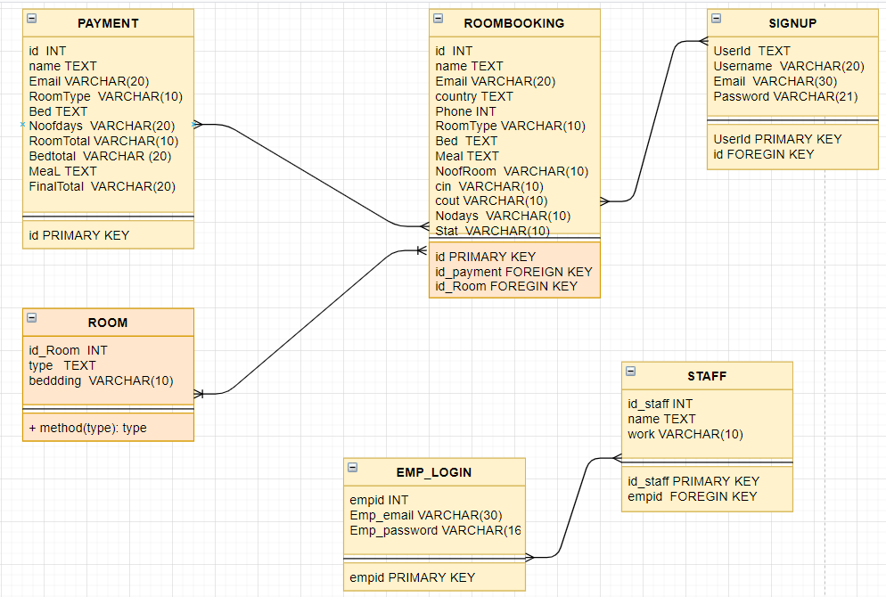

**NORMALIZATION OF FUNCTIONAL DEPENDENCIES**

· **1NF**: Ensure atomic columns.

· **2NF**: Remove partial dependencies

· **3NF**: Remove transitive dependencies

**i.Table emp_login:**

|  |  |  |
| --- | --- | --- |
| empid | Emp_Email | Emp_Password |
|  |  |  |
|  |  |  |

The relation is already in 1NF, 2NF, and 3NF because:

1. It has atomic columns (1NF).
2. Non-key columns are fully dependent on the primary key (2NF).
3. There are no transitive dependencies (3NF).

**ii.Table room**

|  |  |  |
| --- | --- | --- |
| id | type | bedding |
| 1 | Superior Room | Single |
| 2 | Deluxe Room | Double |

This table is already in 1NF because of the atomic values in each attribute

To achieve 2NF, we ensure that the table is already in 1NF, and all non-key columns are fully dependent on the primary key. In this case, type and bedding are already fully dependent on the primary key id, so the table is in 2NF.

3NF

Splitting the table ‘room’ into ‘roomTypes’ , ‘bedding’, and ‘rooms’

**Table RoomTypes**:

* type_id (Primary Key)
* type

**Table Beddings**:

* bedding_id (Primary Key)
* bedding

**Table Rooms**:

* id (Primary Key)
* type_id (Foreign Key)
* bedding_id (Foreign Key)

|  |  |
| --- | --- |
| type_id | type |
| 1 | Superior room |
| 2 | Deluxe room |

|  |  |
| --- | --- |
| Bedding_id | bedding |
| 1 | Single |
| 2 | Double |

|  |  |  |
| --- | --- | --- |
| id | type_id | bedding_id |
| 1 | 1 | 1 |
| 2 | 2 | 2 |

**SQL QUERY CODES:**

-- phpMyAdmin SQL Dump

-- version 5.2.0

-- https://www.phpmyadmin.net/

--

-- Host: 127.0.0.1

-- Generation Time: Nov 10, 2022 at 11:19 AM

-- Server version: 10.4.24-MariaDB

-- PHP Version: 8.1.6

SET SQL_MODE = "NO_AUTO_VALUE_ON_ZERO";

START TRANSACTION;

SET time_zone = "+00:00";

/*!40101 SET @OLD_CHARACTER_SET_CLIENT=@@CHARACTER_SET_CLIENT */;

/*!40101 SET @OLD_CHARACTER_SET_RESULTS=@@CHARACTER_SET_RESULTS */;

/*!40101 SET @OLD_COLLATION_CONNECTION=@@COLLATION_CONNECTION */;

/*!40101 SET NAMES utf8mb4 */;

--

-- Database: `bluebirdhotel`

-- User: `bluebird_user`

-- Password:   `password`

--

DROP DATABASE IF EXISTS bluebirdhotel;

CREATE DATABASE IF NOT EXISTS bluebirdhotel;

DROP USER IF EXISTS'bluebird_user'@'%';

CREATE USER IF NOT EXISTS 'bluebird_user'@'%' IDENTIFIED BY 'password';

GRANT ALL PRIVILEGES ON bluebirdhotel.* TO 'bluebird_user'@'%';

USE bluebirdhotel;

-- --------------------------------------------------------

--

-- Table structure for table `emp_login`

--

CREATE TABLE `emp_login` (

  `empid` int(100) NOT NULL,

  `Emp_Email` varchar(50) NOT NULL,

  `Emp_Password` varchar(50) NOT NULL

) ENGINE=InnoDB DEFAULT CHARSET=utf8mb4;

--

-- Dumping data for table `emp_login`

--

INSERT INTO `emp_login` (`empid`, `Emp_Email`, `Emp_Password`) VALUES

(1, 'Admin@gmail.com', '1234');

-- --------------------------------------------------------

--

-- Table structure for table `payment`

--

CREATE TABLE `payment` (

  `id` int(30) NOT NULL,

  `Name` varchar(30) NOT NULL,

  `Email` varchar(30) NOT NULL,

  `RoomType` varchar(30) NOT NULL,

  `Bed` varchar(30) NOT NULL,

  `NoofRoom` int(30) NOT NULL,

  `cin` date NOT NULL,

  `cout` date NOT NULL,

  `noofdays` int(30) NOT NULL,

  `roomtotal` double(8,2) NOT NULL,

  `bedtotal` double(8,2) NOT NULL,

  `meal` varchar(30) NOT NULL,

  `mealtotal` double(8,2) NOT NULL,

  `finaltotal` double(8,2) NOT NULL

) ENGINE=InnoDB DEFAULT CHARSET=utf8mb4;

--

-- Dumping data for table `payment`

--

INSERT INTO `payment` (`id`, `Name`, `Email`, `RoomType`, `Bed`, `NoofRoom`, `cin`, `cout`, `noofdays`, `roomtotal`, `bedtotal`, `meal`, `mealtotal`, `finaltotal`) VALUES

(41, 'Tushar pankhaniya', 'pankhaniyatushar9@gmail.com', 'Single Room', 'Single', 1, '2022-11-09', '2022-11-10', 1, 1000.00, 10.00, 'Room only', 0.00, 1010.00);

-- --------------------------------------------------------

--

-- Table structure for table `room`

--

CREATE TABLE `room` (

  `id` int(30) NOT NULL,

  `type` varchar(50) NOT NULL,

  `bedding` varchar(50) NOT NULL

) ENGINE=InnoDB DEFAULT CHARSET=utf8mb4;

--

-- Dumping data for table `room`

--

INSERT INTO `room` (`id`, `type`, `bedding`) VALUES

(4, 'Superior Room', 'Single'),

(6, 'Superior Room', 'Triple'),

(7, 'Superior Room', 'Quad'),

(8, 'Deluxe Room', 'Single'),

(9, 'Deluxe Room', 'Double'),

(10, 'Deluxe Room', 'Triple'),

(11, 'Guest House', 'Single'),

(12, 'Guest House', 'Double'),

(13, 'Guest House', 'Triple'),

(14, 'Guest House', 'Quad'),

(16, 'Superior Room', 'Double'),

(20, 'Single Room', 'Single'),

(22, 'Superior Room', 'Single'),

(23, 'Deluxe Room', 'Single'),

(24, 'Deluxe Room', 'Triple'),

(27, 'Guest House', 'Double'),

(30, 'Deluxe Room', 'Single');

-- --------------------------------------------------------

--

-- Table structure for table `roombook`

--

CREATE TABLE `roombook` (

  `id` int(10) NOT NULL,

  `Name` varchar(50) NOT NULL,

  `Email` varchar(50) NOT NULL,

  `Country` varchar(30) NOT NULL,

  `Phone` varchar(30) NOT NULL,

  `RoomType` varchar(30) NOT NULL,

  `Bed` varchar(30) NOT NULL,

  `Meal` varchar(30) NOT NULL,

  `NoofRoom` varchar(30) NOT NULL,

  `cin` date NOT NULL,

  `cout` date NOT NULL,

  `nodays` int(50) NOT NULL,

  `stat` varchar(30) NOT NULL

) ENGINE=InnoDB DEFAULT CHARSET=utf8mb4;

--

-- Dumping data for table `roombook`

--

INSERT INTO `roombook` (`id`, `Name`, `Email`, `Country`, `Phone`, `RoomType`, `Bed`, `Meal`, `NoofRoom`, `cin`, `cout`, `nodays`, `stat`) VALUES

(41, 'Tushar pankhaniya', 'pankhaniyatushar9@gmail.com', 'India', '9313346569', 'Single Room', 'Single', 'Room only', '1', '2022-11-09', '2022-11-10', 1, 'Confirm');

-- --------------------------------------------------------

--

-- Table structure for table `signup`

--

CREATE TABLE `signup` (

  `UserID` int(100) NOT NULL,

  `Username` varchar(50) NOT NULL,

  `Email` varchar(50) NOT NULL,

  `Password` varchar(50) NOT NULL

) ENGINE=InnoDB DEFAULT CHARSET=utf8mb4;

--

-- Dumping data for table `signup`

--

INSERT INTO `signup` (`UserID`, `Username`, `Email`, `Password`) VALUES

(1, 'Tushar Pankhaniya', 'tusharpankhaniya2202@gmail.com', '123');

-- --------------------------------------------------------

--

-- Table structure for table `staff`

--

CREATE TABLE `staff` (

  `id` int(30) NOT NULL,

  `name` varchar(30) NOT NULL,

  `work` varchar(30) NOT NULL

) ENGINE=InnoDB DEFAULT CHARSET=utf8mb4;

--

-- Dumping data for table `staff`

--

INSERT INTO `staff` (`id`, `name`, `work`) VALUES

(1, 'Tushar pankhaniya', 'Manager'),

(3, 'rohit patel', 'Cook'),

(4, 'Dipak', 'Cook'),

(5, 'tirth', 'Helper'),

(6, 'mohan', 'Helper'),

(7, 'shyam', 'cleaner'),

(8, 'rohan', 'weighter'),

(9, 'hiren', 'weighter'),

(10, 'nikunj', 'weighter'),

(11, 'rekha', 'Cook');

--

-- Indexes for dumped tables

--

--

-- Indexes for table `emp_login`

--

ALTER TABLE `emp_login`

  ADD PRIMARY KEY (`empid`);

--

-- Indexes for table `payment`

--

ALTER TABLE `payment`

  ADD PRIMARY KEY (`id`);

--

-- Indexes for table `room`

--

ALTER TABLE `room`

  ADD PRIMARY KEY (`id`);

--

-- Indexes for table `roombook`

--

ALTER TABLE `roombook`

  ADD PRIMARY KEY (`id`);

--

-- Indexes for table `signup`

--

ALTER TABLE `signup`

  ADD PRIMARY KEY (`UserID`);

--

-- Indexes for table `staff`

--

ALTER TABLE `staff`

  ADD PRIMARY KEY (`id`);

--

-- AUTO_INCREMENT for dumped tables

--

--

-- AUTO_INCREMENT for table `emp_login`

--

ALTER TABLE `emp_login`

  MODIFY `empid` int(100) NOT NULL AUTO_INCREMENT, AUTO_INCREMENT=5;

--

-- AUTO_INCREMENT for table `room`

--

ALTER TABLE `room`

  MODIFY `id` int(30) NOT NULL AUTO_INCREMENT, AUTO_INCREMENT=31;

--

-- AUTO_INCREMENT for table `roombook`

--

ALTER TABLE `roombook`

  MODIFY `id` int(10) NOT NULL AUTO_INCREMENT, AUTO_INCREMENT=51;

--

-- AUTO_INCREMENT for table `signup`

--

ALTER TABLE `signup`

  MODIFY `UserID` int(100) NOT NULL AUTO_INCREMENT, AUTO_INCREMENT=7;

--

-- AUTO_INCREMENT for table `staff`

--

ALTER TABLE `staff`

  MODIFY `id` int(30) NOT NULL AUTO_INCREMENT, AUTO_INCREMENT=12;

COMMIT;

/*!40101 SET CHARACTER_SET_CLIENT=@OLD_CHARACTER_SET_CLIENT */;

/*!40101 SET CHARACTER_SET_RESULTS=@OLD_CHARACTER_SET_RESULTS */;

/*!40101 SET COLLATION_CONNECTION=@OLD_COLLATION_CONNECTION */;